**Vanier College**

**Computer Science Department**

**420-320-VA Database I**

**Fall 2018**

**Lab/Assignment Number and Title:**

Assignment 1: Comprehension Questions & the Pizza-Plus Database

**Submitted by:**

**Student Name:** Marissa Gonçalves

**Student ID:** 1775227

**Part I:**

1. According to the entity integrity principle regarding the relational database, it seems that the primary key (ID) in the first table follows this principle since the numeric values are unique and non-null. However, the primary key (CustomerID) in the second table doesn’t match the rule since the field contains a null value. It is important that relational databases should only contain non-null values located in the primary key. While mentioning about the referential integrity principle, the foreign key (CustomerID) for the second table, doesn’t contain the value 140, located from the secondary key in the first table. This rule can be easily followed when a primary key in one table must reference all values from a foreign key of another table.
2. An example of a secondary key situated in a Student entity can include the StudentName (name of the student).
3. a) One-to-Many Relationship

b) One-to-Many Relationship

c) Many-to-Many Relationship

d) One-to-One Relationship

1. a) The ISBN is the primary key, since each ISBN is unique for each individual book. There is also important that the ISBN field should not contain one null record. Every book must have an ISBN, to distinguish each of them.

b) It is not acceptable because there is a possibility that two or more book owners (BookOwner) can have the same name. Thus, these owners are not considered to be unique, defying the entity integrity principle where each book and owner must be unique.

c) An appropriate composite primary key for the PersonalLibrary table can be the owner ID (OwnerID), which distinguishes the identification for each individual owner.

**Part II: (A - Database Design)**

1. There are two entity sets that make up this database. The first one will manage the customers’ records. The attributes of this set include the customer’s ID, first name, last name, phone number, address, city, province, postal code and their loyalty rating ranging from 1 to 5. The rating is set to 1 by default. The second entity organizes the customers’ orders. The attributes of this set include the customer’s order ID, customer ID, order date and time, and the number of pizzas ordered for each of the following sizes: small, medium, large and extra large.
2. **E-R Entity-Relationship Diagram:**

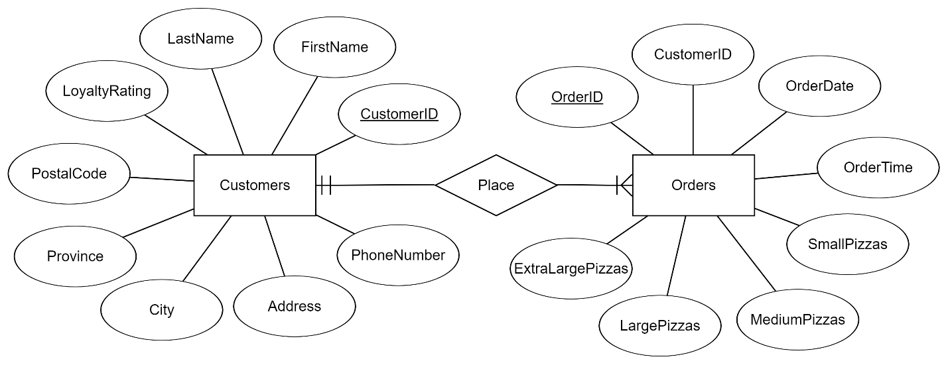

1. **Set 1:** Customers (CustomerID, FirstName, LastName, PhoneNumber, Address, City, Province, PostalCode, LoyaltyRating)

**Set 2:** Orders (OrderID, CustomerID, OrderDate, OrderTime, SmallPizzas, MediumPizzas, LargePizzas, ExtraLargePizzas)

1. The primary key from the Customers table which is CustomerID, is the foreign key of the Orders table. This allows to distinguish the order identification with the specific customer.

**Part II: (B - Database Implementation)**

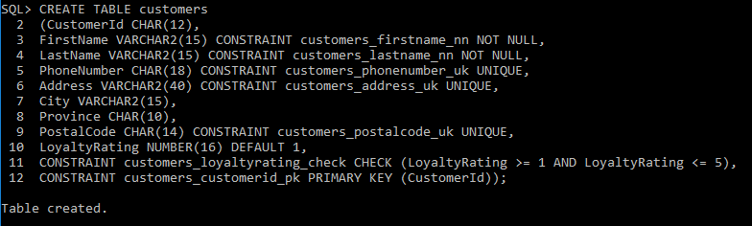

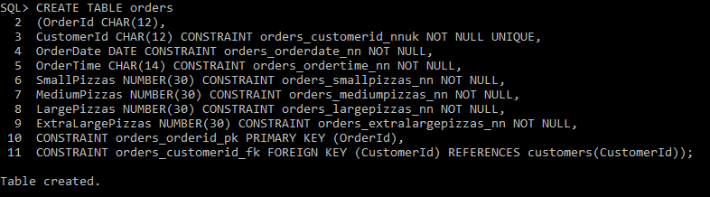

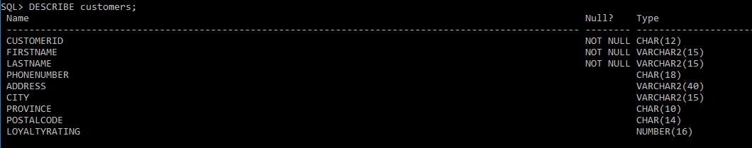

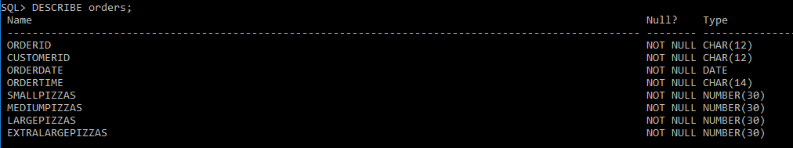

1. 
2. 